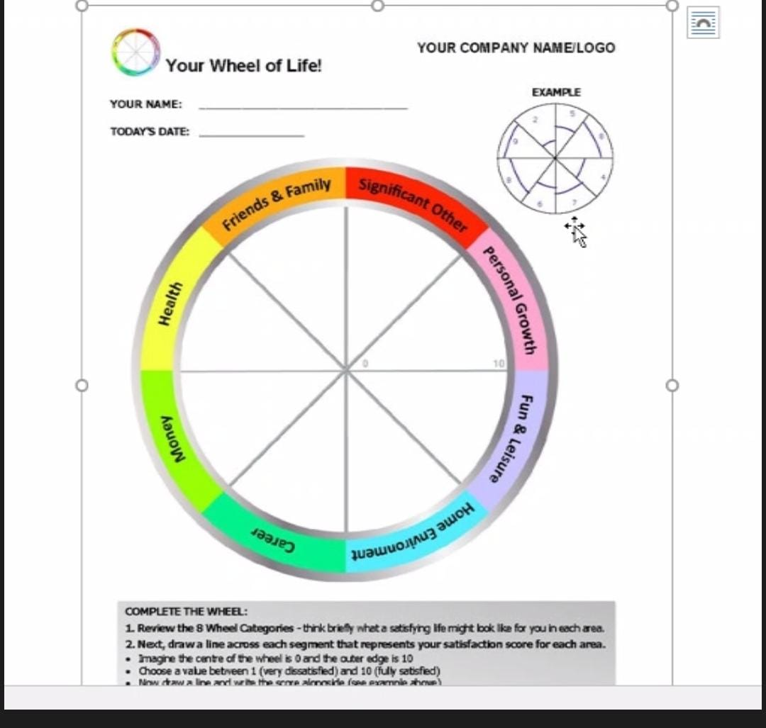

Soumya kaddouri

Six weeks is too short to see me differently, but I want to be more organized, productive, happy, and satisfied with my life, learning and discovering new things that can help me with my study, surrounded by people who love me.